Software Requirements Specification (SRS)

FinTracker – Finance Management App
1/2026
Prepared by Nguyen Ngoc Tuan

I. Introduction.

1. Propose.
- FinTrack is a personal finance app for tracking day-to-day money movement.
- It helps users manage expense/income books, monitor spending patterns, plan savings goals, and receive reminders for recurring bills and savings milestones.
- The product is designed as a local-first mobile app (single-device usage pattern).

2. Scope.
- Multi-book finance tracking.
- Transaction management (income/expense, categories, notes, date, optional image).
- Analytics dashboards/charts.
- Savings goals (flexible and periodic).
- Recurring invoice/bill reminders.
- Notification center.
- Settings (language, currency, theme color, authentication).

3. Target Users.
- Individual users managing personal finances.
- Users who want simple budgeting and tracking without complex accounting workflows.
- Users needing bilingual UI (Vietnamese/English) and basic multi-currency display (VND/USD/EUR).
- Users who want reminder-driven financial discipline (recurring bills, periodic savings).

II. System Overview.
- Product type: Mobile personal finance tracker.
- Scope: Transaction tracking, book management, savings planning, recurring invoice reminders, analytics, personalization.
- Deployment style: Local-first app using on-device storage and device notifications.

III. Specific Requirements.

1. Functional Requirements.
FR-A01: The system shall present onboarding to first-time users.
Acceptance Criteria:
- On first launch, onboarding screens are displayed before main app content
- Onboarding can be completed by the user via explicit completion action
- Returning users who already completed onboarding do not see onboarding again
- User can continue to the next setup step after onboarding completion

FR-A02: The system shall allow initial book setup before normal use.
Acceptance Criteria:
- After onboarding, user is prompted to create at least one finance book
- Book name is required and cannot be empty
- Default currency is prefilled and can be changed during setup
- User cannot enter normal app flow until minimum required setup is completed

FR-A03: The system shall persist first-visit completion status.
Acceptance Criteria:
- Completion status is stored locally after onboarding/setup is finished
- App restart preserves first-visit completion status
- Clearing app data resets first-visit completion status
- Status read is available at startup to determine entry flow

FR-B01: The system shall support Google sign-in and sign-out.
Acceptance Criteria:
- User can initiate Google sign-in from authentication UI
- Successful sign-in grants access to authenticated features
- User can sign out from settings/profile area
- After sign-out, authenticated session is invalidated locally

FR-B02: The system shall persist basic session/profile metadata locally.
Acceptance Criteria:
- On successful sign-in, profile metadata (e.g., user id, name, email/avatar when available) is stored locally
- Stored metadata is retrievable after app restart
- Metadata is removed or marked invalid after sign-out
- Local persistence logic handles null/optional fields safely

FR-B03: The system shall attempt silent session restore at startup.
Acceptance Criteria:
- On app startup, system checks for existing valid sign-in session
- If valid session exists, user is restored without manual sign-in
- If restore fails or session is invalid, app navigates to unauthenticated flow
- Restore attempt completes without blocking app startup indefinitely

FR-C01: The system shall allow creation of multiple finance books.
Acceptance Criteria:
- User can create more than one book from book management UI
- Each created book is stored with unique identifier
- Required fields are validated before saving
- Newly created book appears in book list after save

FR-C02: The system shall allow selecting active/current book.
Acceptance Criteria:
- User can select one book as active/current at a time
- Active book state is persisted locally
- On app restart, previously active book is restored if still exists
- Data views are scoped to the active book by default

FR-C03: The system shall allow editing and deleting books.
Acceptance Criteria:
- User can edit editable properties of an existing book
- Updated values are saved and reflected in book list/detail views
- User can delete a book with confirmation
- Deleting a book updates active-book selection according to defined fallback rule

FR-C04: The system shall associate financial records with a book.
Acceptance Criteria:
- Every transaction, invoice, and savings-related record stores a book identifier
- Creating a record requires a valid target book context
- Querying records by active book returns only matching records
- Switching active book changes scoped records in lists/analytics

FR-D01: The system shall allow users to create a transaction.
Acceptance Criteria:
- Amount is required and must be a positive number
- User must select transaction type (income/expense)
- User must select a category
- Date defaults to current date if not provided
- Transaction is saved successfully
- Book balance is updated after saving

FR-D02: The system shall allow users to edit a transaction.
Acceptance Criteria:
- User can open an existing transaction in edit mode
- Edited fields are validated using the same rules as creation
- Saving changes updates transaction detail and list views
- Balance and summaries are recalculated after successful edit

FR-D03: The system shall allow users to delete a transaction.
Acceptance Criteria:
- User can trigger delete action from transaction detail/list
- System requests confirmation before permanent deletion
- Deleted transaction is removed from storage and UI lists
- Balance and summaries are recalculated after successful deletion

FR-D04: The system shall support category and date assignment for transactions.
Acceptance Criteria:
- Category selection is available for each transaction
- Transaction date can be selected using date input control
- Category and date values are persisted with the transaction
- Filtering/grouping features can use stored category/date data

FR-D05: The system shall support note and optional image path metadata for transactions.
Acceptance Criteria:
- User can add or edit a free-text note for a transaction
- User can attach or set an optional image path/URI
- Empty image path is accepted and does not block save
- Note and image path values are persisted and retrievable

FR-D06: The system shall update summaries and lists after transaction changes.
Acceptance Criteria:
- Add/edit/delete operations refresh affected transaction lists
- Dashboard/book summaries reflect latest transaction data
- Any cached totals are invalidated or recalculated correctly
- UI update occurs without requiring manual app restart

FR-E01: The system shall provide chart-based analysis for financial records.
Acceptance Criteria:
- Analytics screen displays at least one chart visualization for records
- Chart data source is derived from stored financial records
- Empty-state UI is shown when no data is available
- Chart rendering handles typical dataset sizes without crash

FR-E02: The system shall support period-based filtering.
Acceptance Criteria:
- User can select predefined or custom time periods for analytics
- Only records within selected period are included in calculations
- Changing period updates chart and totals accordingly
- Selected period state is visible in analytics UI

FR-E03: The system shall support active-book scoped analytics.
Acceptance Criteria:
- Analytics calculations use records of active/current book only
- Switching active book refreshes analytics data immediately
- No cross-book aggregation is shown unless explicitly requested
- Empty-state appears when selected book has no records

FR-F01: The system shall support flexible savings goals.
Acceptance Criteria:
- User can create savings goals with target name and target amount
- Goal target amount must be greater than zero
- User can edit and delete savings goals
- Savings goals are listed with current status/progress

FR-F02: The system shall support periodic savings goals with frequency and periodic amount.
Acceptance Criteria:
- User can set periodic frequency (e.g., daily/weekly/monthly)
- User can set periodic contribution amount
- Frequency and periodic amount are validated before saving
- Periodic configuration is persisted and shown in goal details

FR-F03: The system shall store and display deposit history.
Acceptance Criteria:
- User can record deposits linked to a savings goal
- Each deposit stores amount, date/time, and goal reference
- Deposit entries appear in chronological history list
- Deposit history is retrievable after app restart

FR-F04: The system shall compute progress and completion status.
Acceptance Criteria:
- Goal progress is calculated from total deposits versus target amount
- Completion status is set when deposited total reaches or exceeds target
- Progress indicators update after each deposit/edit/delete operation
- Computation handles edge cases such as zero deposits safely

FR-F05: The system shall generate reminder/completion notifications by rule.
Acceptance Criteria:
- Reminder rules can trigger notifications based on periodic settings
- Completion notifications are generated when goal reaches completion condition
- Generated events are persisted to notification storage/inbox
- Duplicate notifications for same event window are prevented by rule

FR-G01: The system shall allow create/read/update/delete of periodic invoices.
Acceptance Criteria:
- User can create periodic invoice records with required fields
- User can view invoice list and detail data
- User can edit existing invoice fields and save changes
- User can delete invoice records with confirmation

FR-G02: The system shall support recurring frequencies and due-date tracking.
Acceptance Criteria:
- Invoice supports configurable recurrence frequency
- Next due date is stored or computed based on frequency rules
- Due-date tracking updates after status transitions or cycle completion
- Invalid recurrence configurations are rejected with validation feedback

FR-G03: The system shall allow paid/unpaid status transitions.
Acceptance Criteria:
- User can mark invoice as paid
- User can revert or set invoice to unpaid when applicable
- Status change updates invoice list indicators immediately
- Status transition updates related due-state logic correctly

FR-G04: The system shall generate due/overdue notifications.
Acceptance Criteria:
- System detects due and overdue invoice conditions
- Matching reminder events are generated for due/overdue states
- Generated events are persisted to notification inbox
- Notification generation respects anti-duplicate rules

FR-G05: The system shall support invoice filtering by book/category/amount range.
Acceptance Criteria:
- User can filter invoice list by active book or selected book
- User can filter by category
- User can filter by min/max amount range with numeric validation
- Filtered result updates list content and count consistently

FR-H01: The system shall store generated reminder events in a notification inbox.
Acceptance Criteria:
- Generated reminder/completion/due events are persisted locally
- Inbox list displays stored events with timestamp and type metadata
- Events remain available after app restart
- Empty-state UI is shown when inbox has no events

FR-H02: The system shall allow mark-read, mark-all-read, and delete-read operations.
Acceptance Criteria:
- User can mark a single notification as read
- User can mark all notifications as read in one action
- User can delete all notifications already marked as read
- Read/unread counters and list states update after each operation

FR-H03: The system shall support item-level deletion and refresh.
Acceptance Criteria:
- User can delete one notification item directly from inbox
- Deletion is persisted and removed from current list view
- Manual refresh reloads inbox data from storage/source
- Refresh keeps consistency between unread counters and items

FR-I01: The system shall allow language selection (at least Vietnamese and English).
Acceptance Criteria:
- Settings provides language selector with at least Vietnamese and English
- Changing language updates app text resources
- Selected language is persisted locally
- Persisted language is restored on next app launch

FR-I02: The system shall allow currency selection (at least VND/USD/EUR).
Acceptance Criteria:
- Settings provides currency options including VND, USD, and EUR
- Selected currency is used in amount formatting across relevant screens
- Currency preference is persisted locally
- Persisted currency is restored on next app launch

FR-I03: The system shall allow theme color selection.
Acceptance Criteria:
- Settings provides selectable theme color options
- Selected theme color applies to supported UI components
- Theme color preference is persisted locally
- Persisted theme color is restored on next app launch

FR-I04: The system shall persist all preferences.
Acceptance Criteria:
- Language, currency, and theme preferences are saved as a single consistent settings state
- Preferences are loaded during app initialization
- Invalid or missing stored preference values fall back to safe defaults
- Preference changes take effect without requiring full reinstall

FR-J01: The system shall run periodic background jobs for reminders.
Acceptance Criteria:
- Background scheduler is configured and registered successfully
- Reminder job runs on defined interval under supported OS constraints
- Job execution logs or status markers are recorded for diagnostics
- Job failure is handled without app crash

FR-J02: The system shall process invoice due-state checks.
Acceptance Criteria:
- Background job evaluates invoice due/overdue status against current date
- Detected due-state changes are stored for downstream notification logic
- Processing scope is limited to valid/active invoice records
- Repeated checks are idempotent for unchanged invoice states

FR-J03: The system shall process savings reminder/completion checks.
Acceptance Criteria:
- Background job evaluates savings goals against reminder and completion rules
- Rule matches generate appropriate reminder/completion events
- Processing considers periodic configuration and current progress values
- Repeated checks are idempotent for unchanged goal states

FR-J04: The system shall publish local device notifications when trigger conditions are met.
Acceptance Criteria:
- Triggered events invoke local notification publishing service
- Notification payload includes required title/body and contextual metadata
- Notifications are delivered to device notification center on supported platforms
- Failures in notification publishing are logged and do not crash the app

2. Non-functional Requirements.
NFR-01: UI interactions shall respond within 200ms for standard user actions under normal personal-data volume.
NFR-02: Local data read/write operations shall complete within 1 second for typical daily usage scenarios.
NFR-03: The system shall maintain smooth navigation with a tab-based primary structure and clear empty/error states.
NFR-04: Core financial data shall persist locally and remain available across app restarts.
NFR-05: The system shall execute scheduled background reminder checks reliably under supported OS constraints.
NFR-06: Core financial features shall support offline usage; internet shall only be required for Google sign-in initiation and related account operations.
NFR-07: The system shall support dynamic language switching between Vietnamese and English without requiring app reinstall.
NFR-08: Financial records and session/profile metadata shall be stored on-device with no enterprise-grade encryption guarantee in the current baseline.
NFR-09: The mobile UI shall be optimized for portrait orientation and common phone screen sizes.
NFR-10: Notification handling shall support required platform permissions and runtime behavior on Android.

3. Data Requirements.
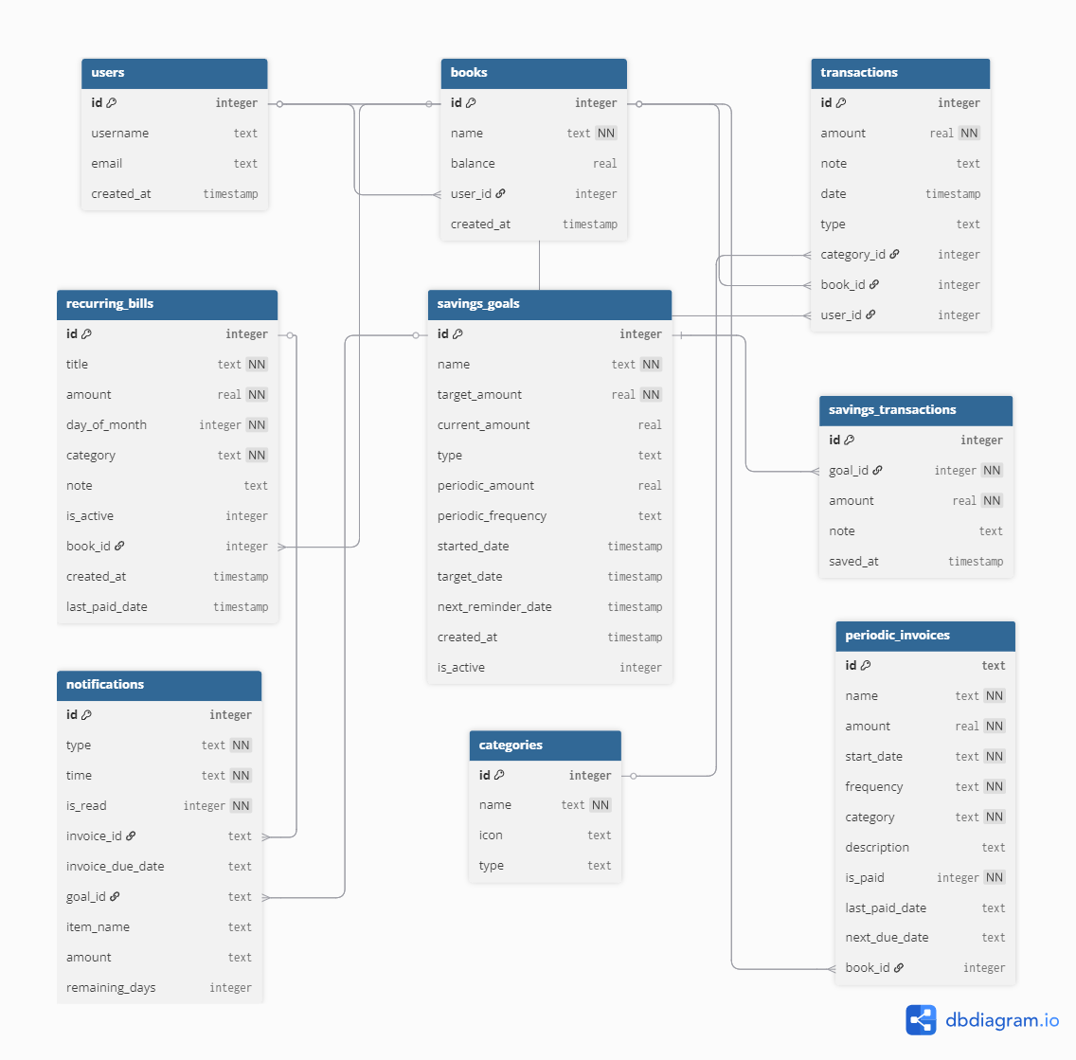
ERD Diagram

IV. Apendices.

Appendix A: User Flow.
- User Flows are defined in PRD – Section 3.

Appendix B: User Stories.
- User Stories are defined in PRD – Section 4.

